Project Title: A Private Git Server on Linux & AWS EC2

# Introduction:

In modern software development, version control is essential for collaboration, code management, and continuous improvement. While popular platforms like GitHub and GitLab offer hosted solutions, many organizations and development teams prefer hosting their own Git servers for increased control, privacy, and security. This project focuses on setting up a **private Git server** on a **Linux** machine using **Git over SSH**, enabling secure and efficient source code management.

This setup empowers teams to:

* Maintain complete control over their codebase.
* Enforce custom access policies.
* Operate independently of third-party platforms.
* Collaborate efficiently within a secure network.

# Objective:

The primary objective of this project is to install and configure a private Git server on a Linux machine to facilitate secure version control and collaborative software

development. The setup aims to provide a reliable and controlled environment for managing source code, ensuring data privacy, user authentication, and repository access control within a team-based setting.

The key goals include:

* Establishing secure SSH access to the Git server for encrypted communication.
* Implementing user authentication mechanisms to manage and restrict access to repositories.
* Creating and managing Git repositories to support multiple projects and contributors.
* Enforcing repository access control, including read/write permissions, to protect sensitive code.

# Outcomes:

* Successfully set up a private Git server on Linux with SSH access for secure communication.
* Implemented user authentication to control access to repositories.
* Established efficient repository management and access control for secure collaboration.
* Enabled a private, self-hosted environment for team-based software development and code sharing.

**Step-by-Step Guide:-**

**Step 1: Create EC2 Instance:**

1. **Navigate to EC2 under the Services section.**

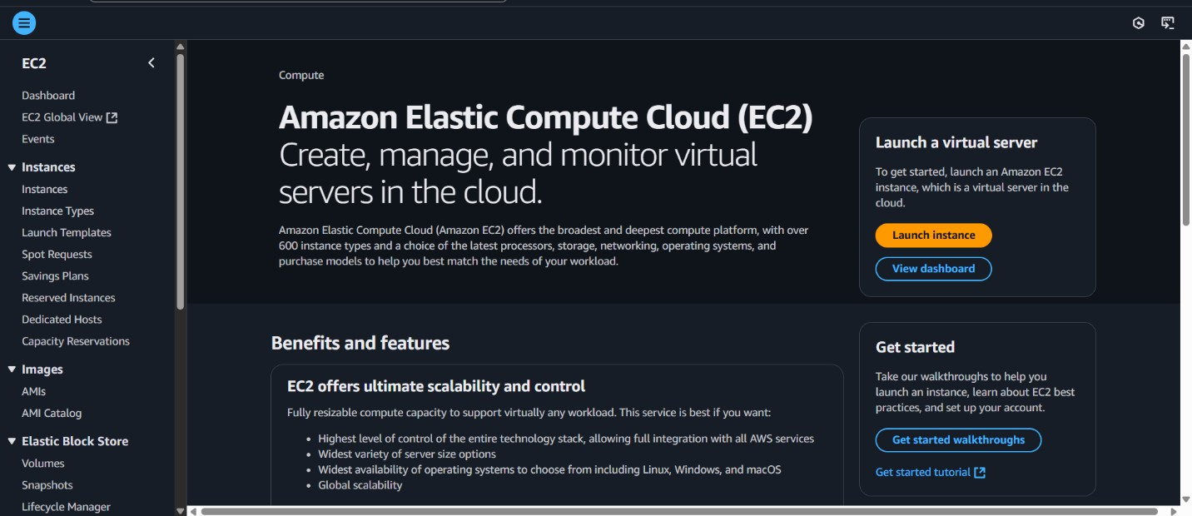

1. **Amazon Machine Image (AMI) And Instance type.**

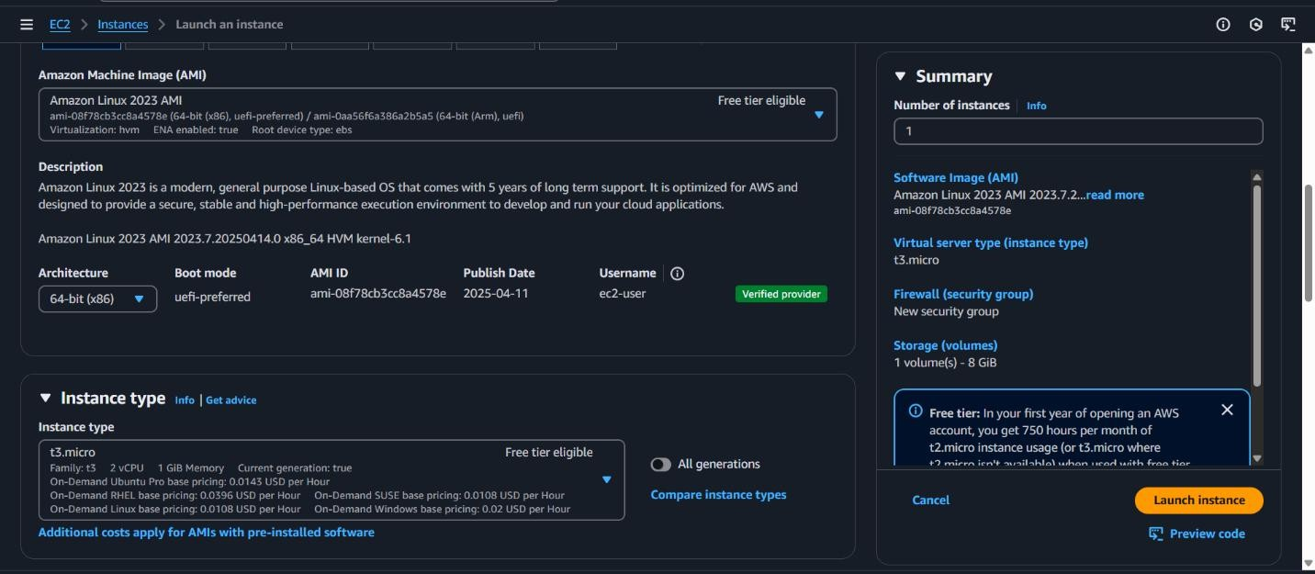

1. **Network Storage.**

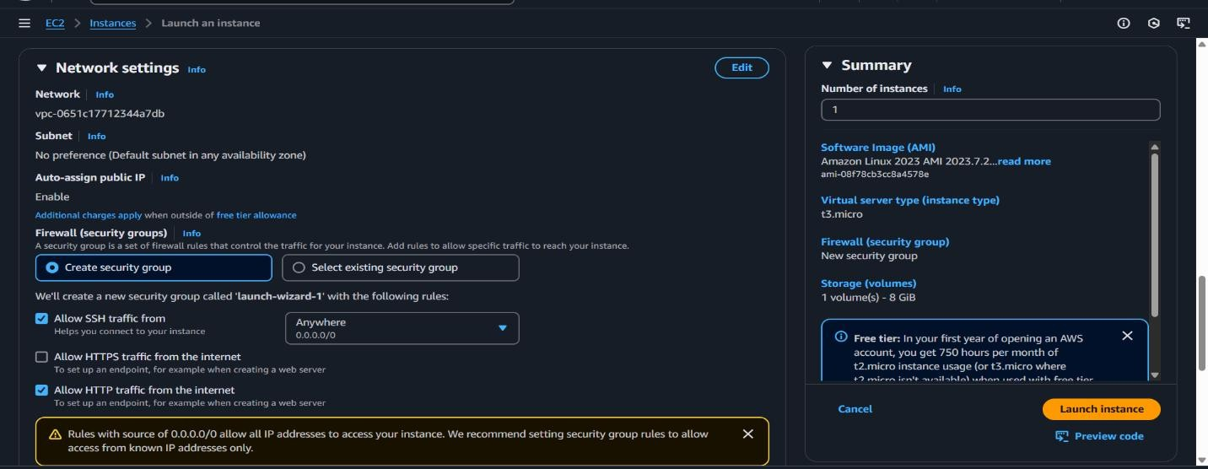

1. **Configure Storage.**

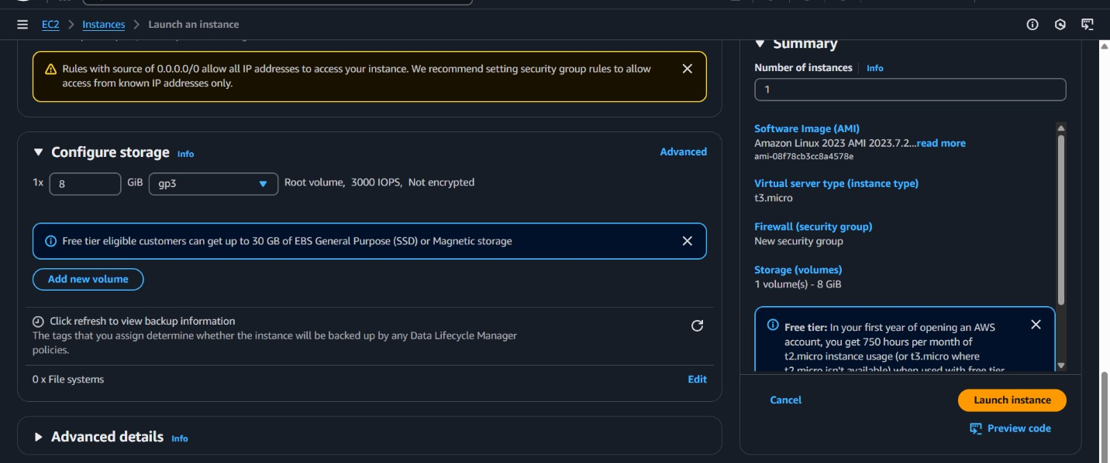

1. **Successfully initiated launch of instance.**

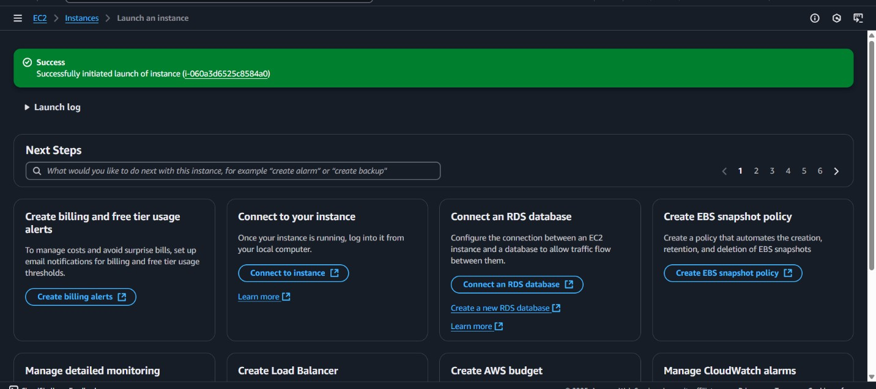

1. **Connect to EC2 Instance.**

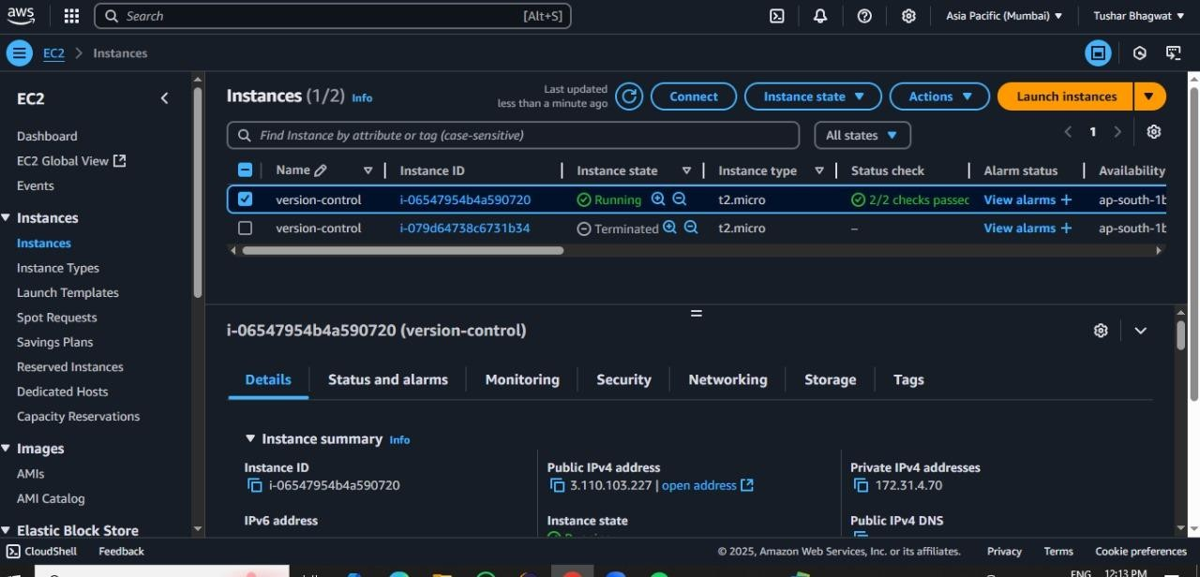

1. **Click on Connect Option.**

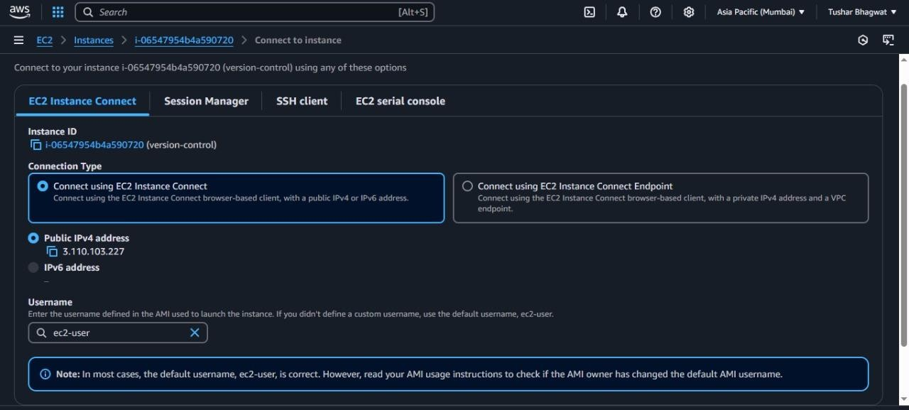

1. **Connect Successfully. Go from local user to root user:**

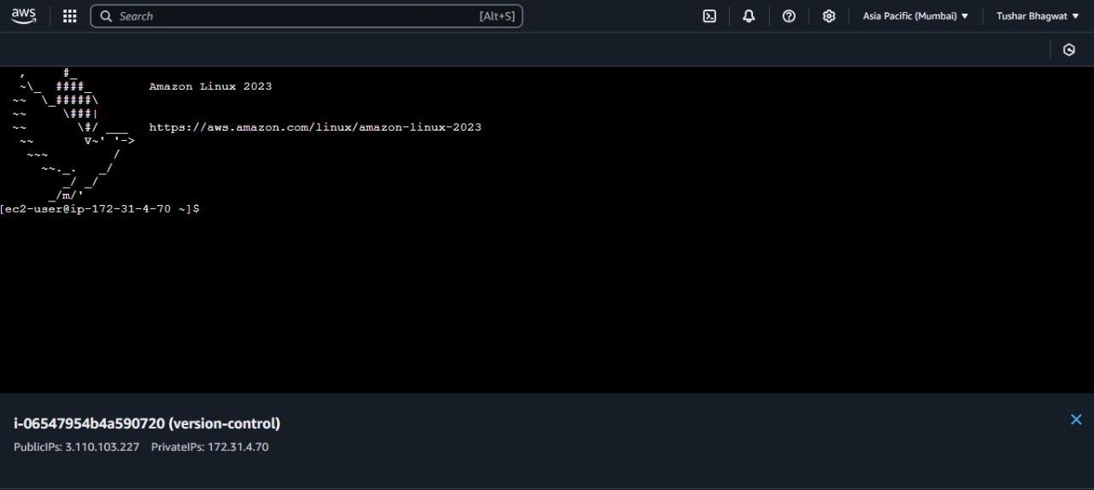

1. **Install Git server.**

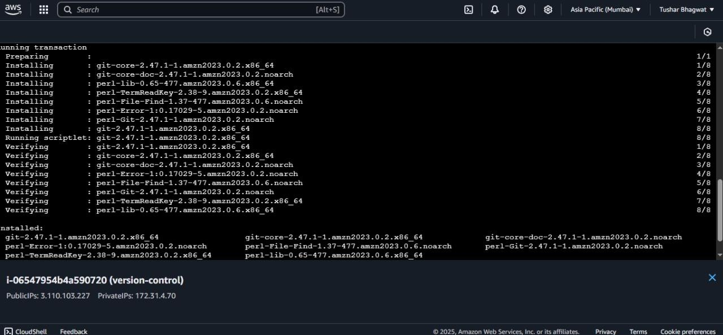

1. Repo of Git

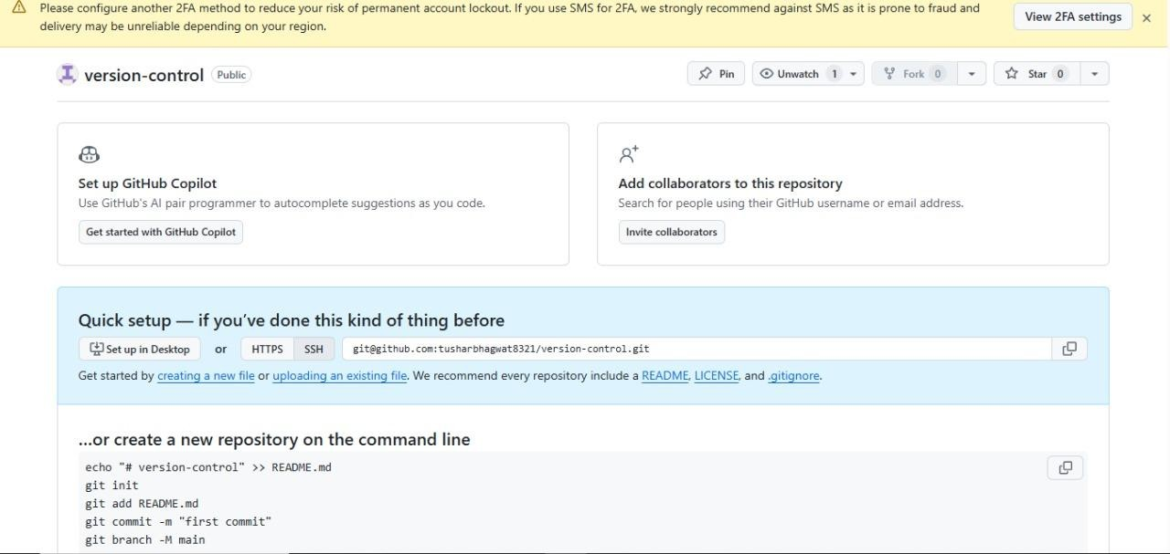

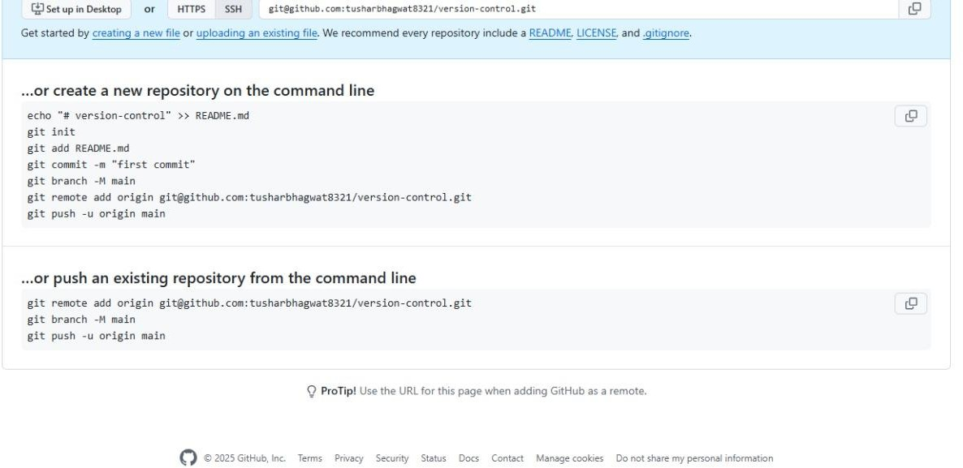

1. Created Successfully SSH-KeyGen

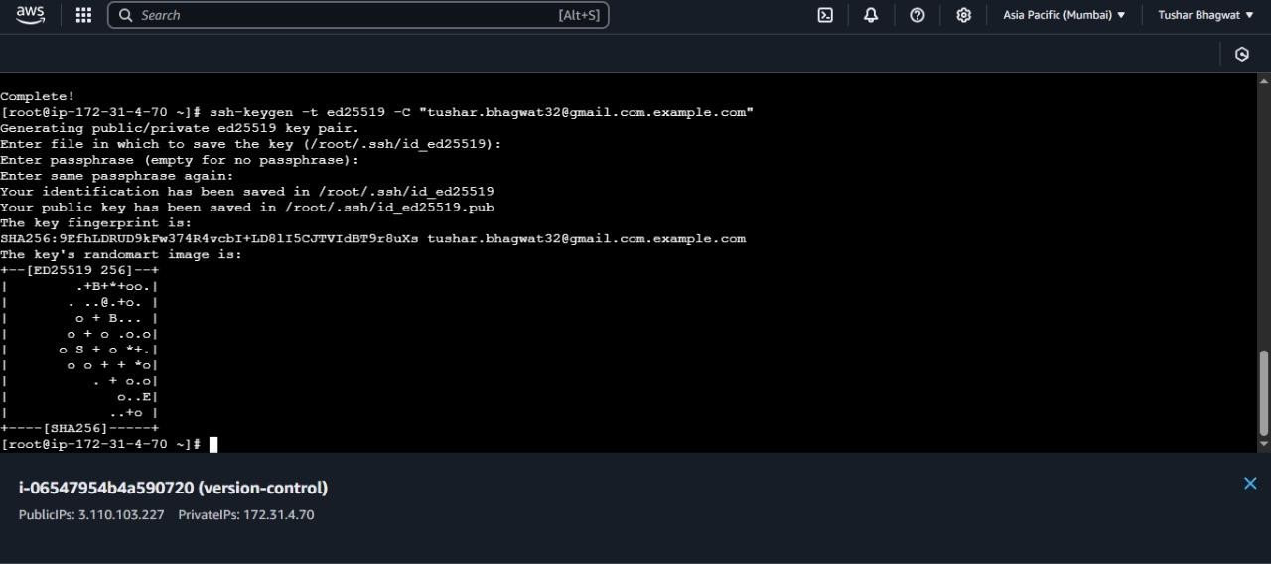

1. Get New SSH-Key

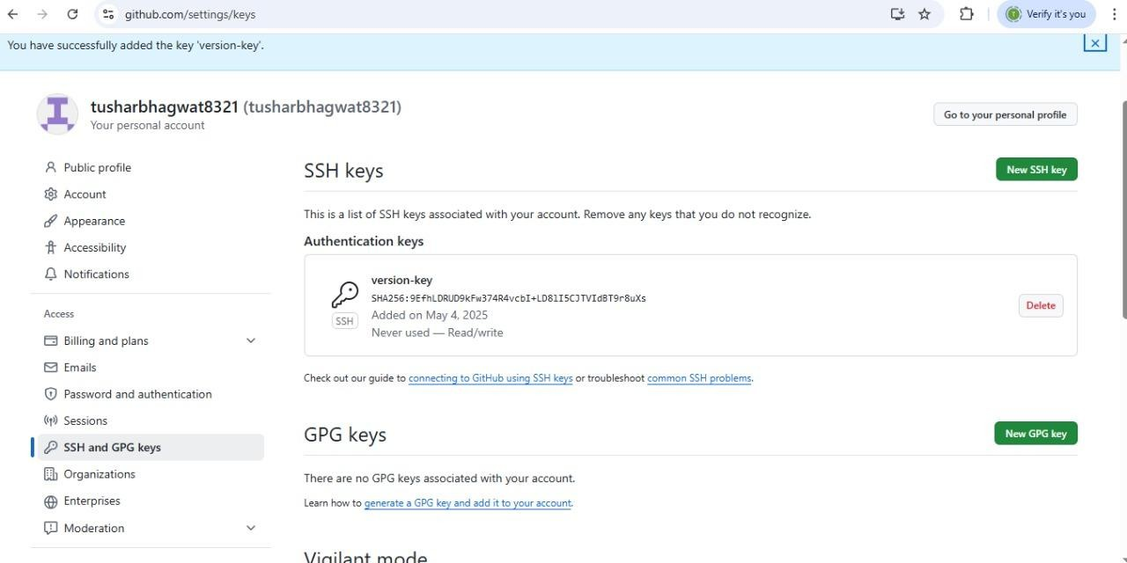

1. Get Access to git Clone

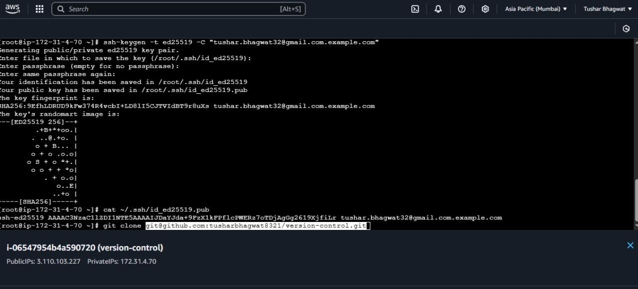

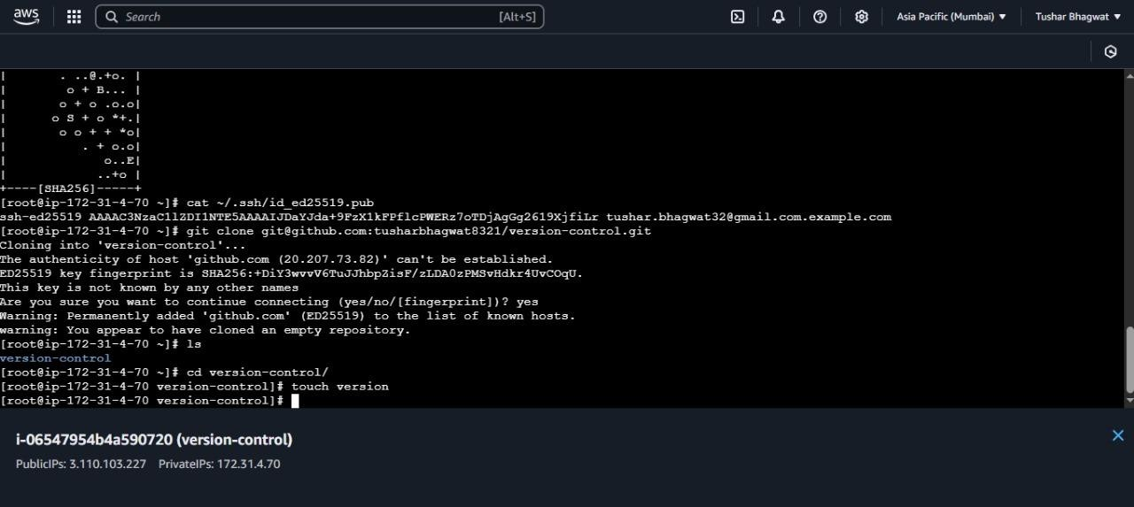

1. Added file Successfully to git

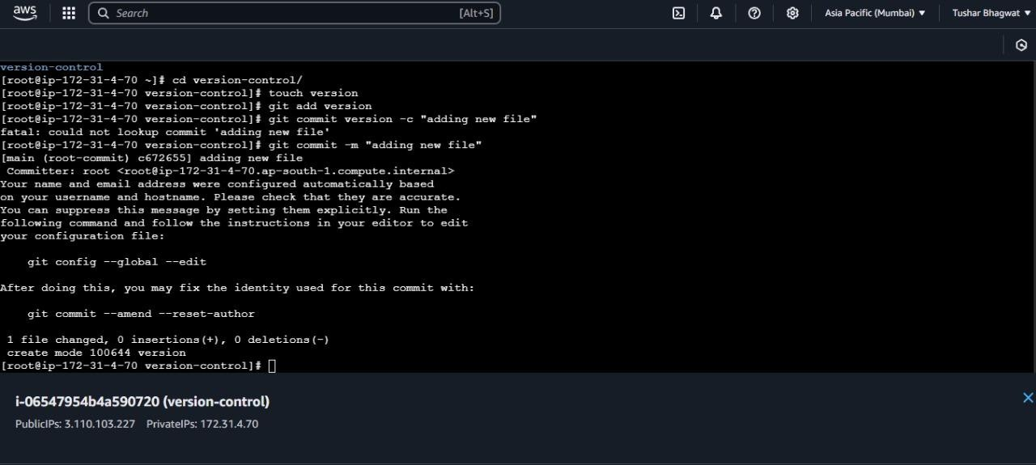

1. Push the file to git Account

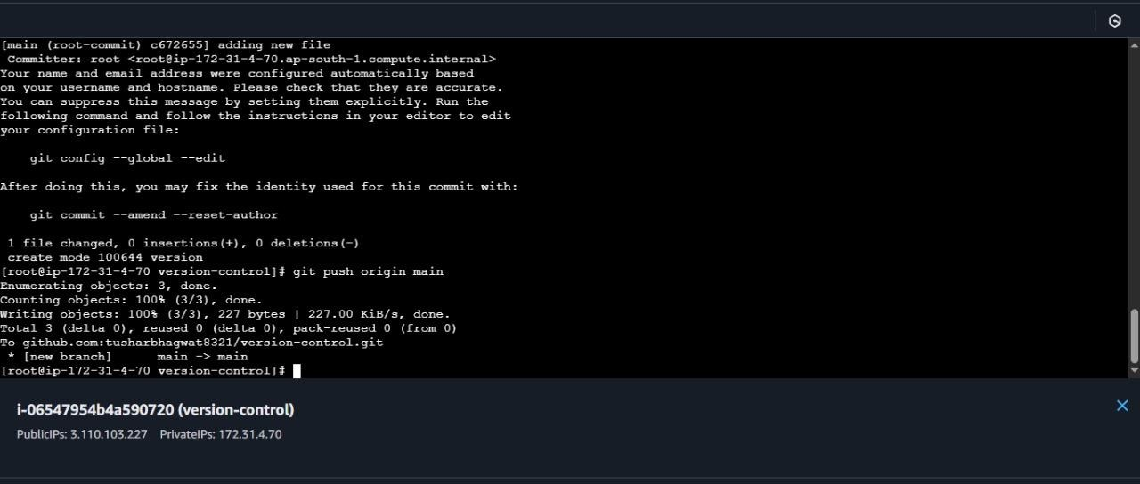

1. Successfully Added Version file to Repo

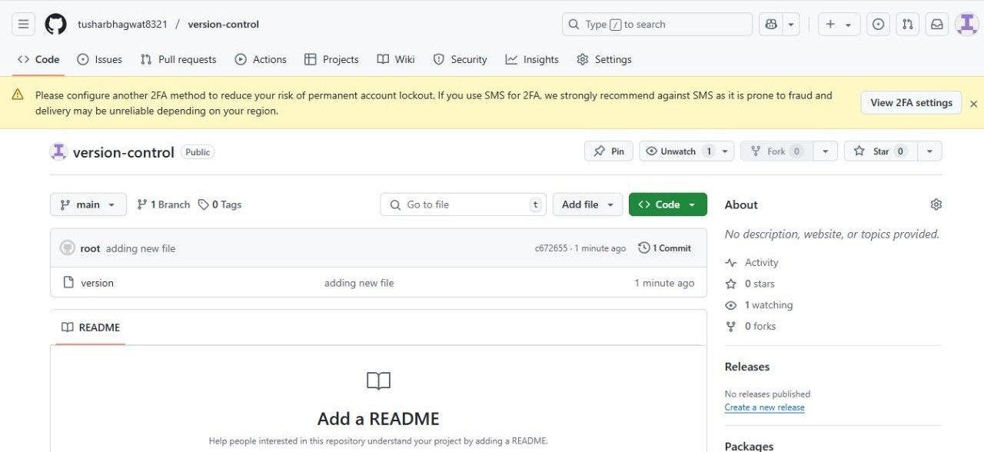

.

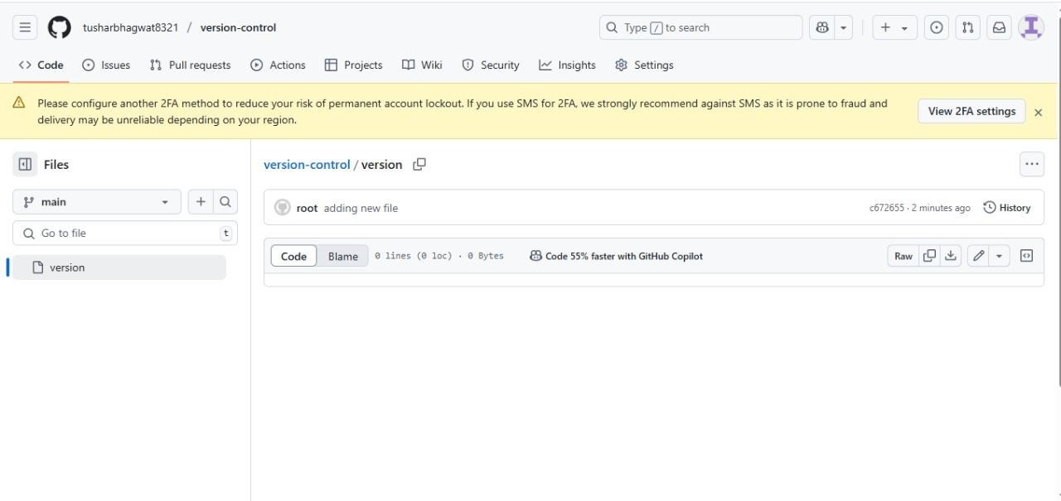

# Summary:

This project involves setting up a private Git server on a Linux machine to enable secure and efficient version control for team-based software development. By using Git with SSH access, it ensures encrypted communication, supports user authentication, and allows full repository management. The server provides a controlled environment for managing code, enhancing collaboration, and maintaining data privacy without relying on third-party hosting services.